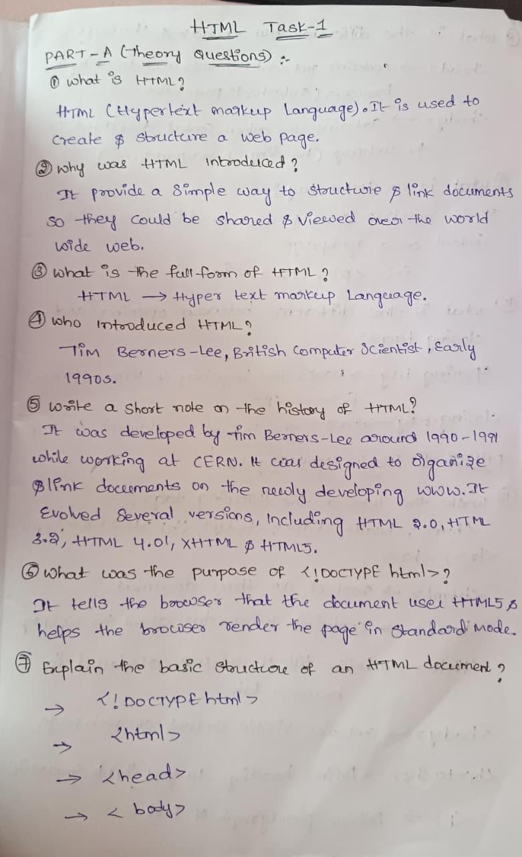
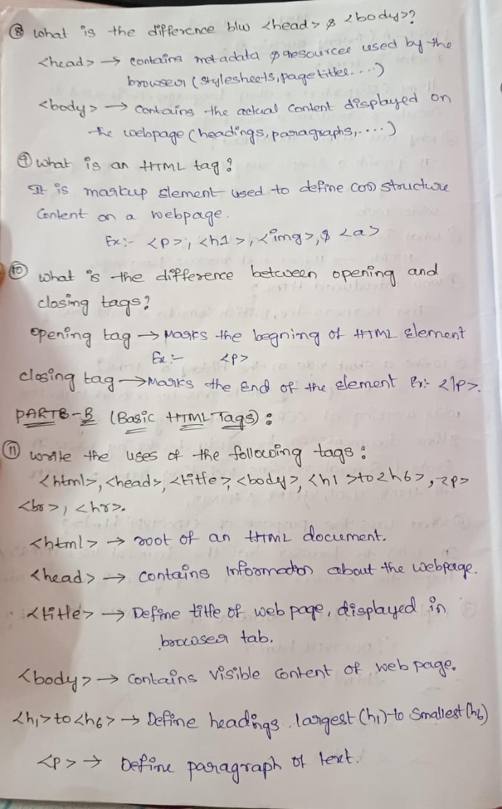
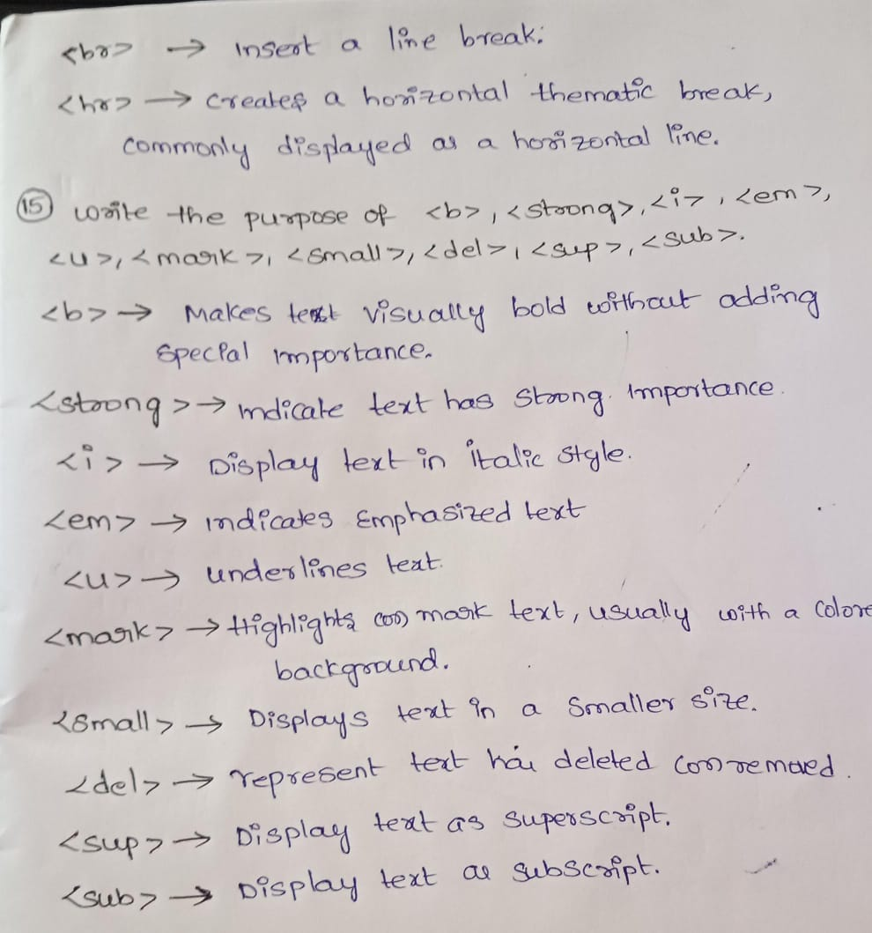
12.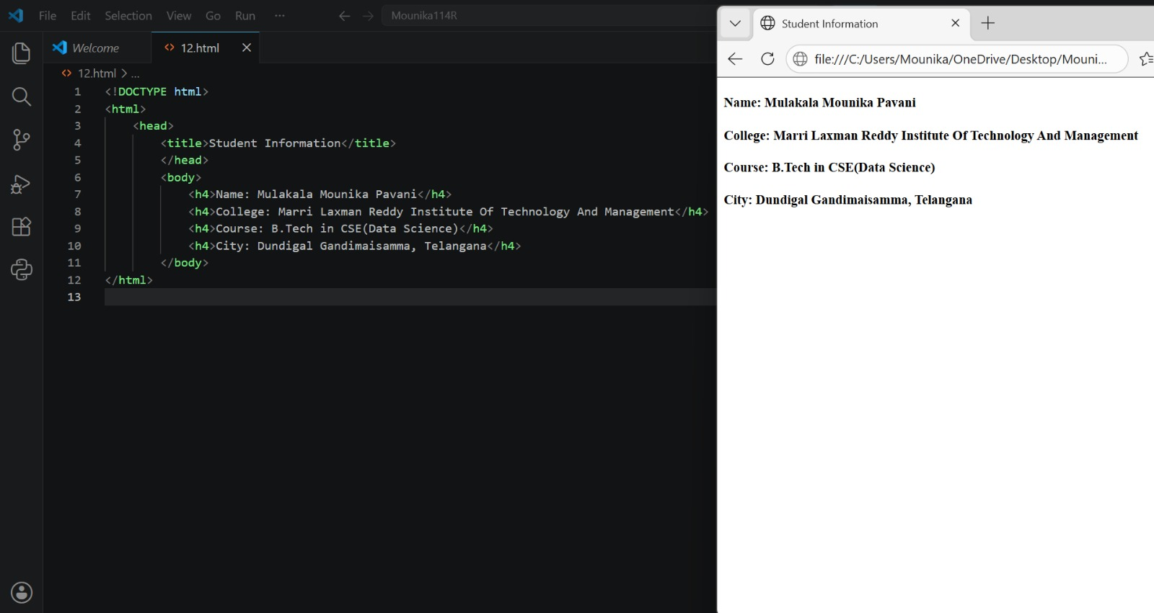
13.
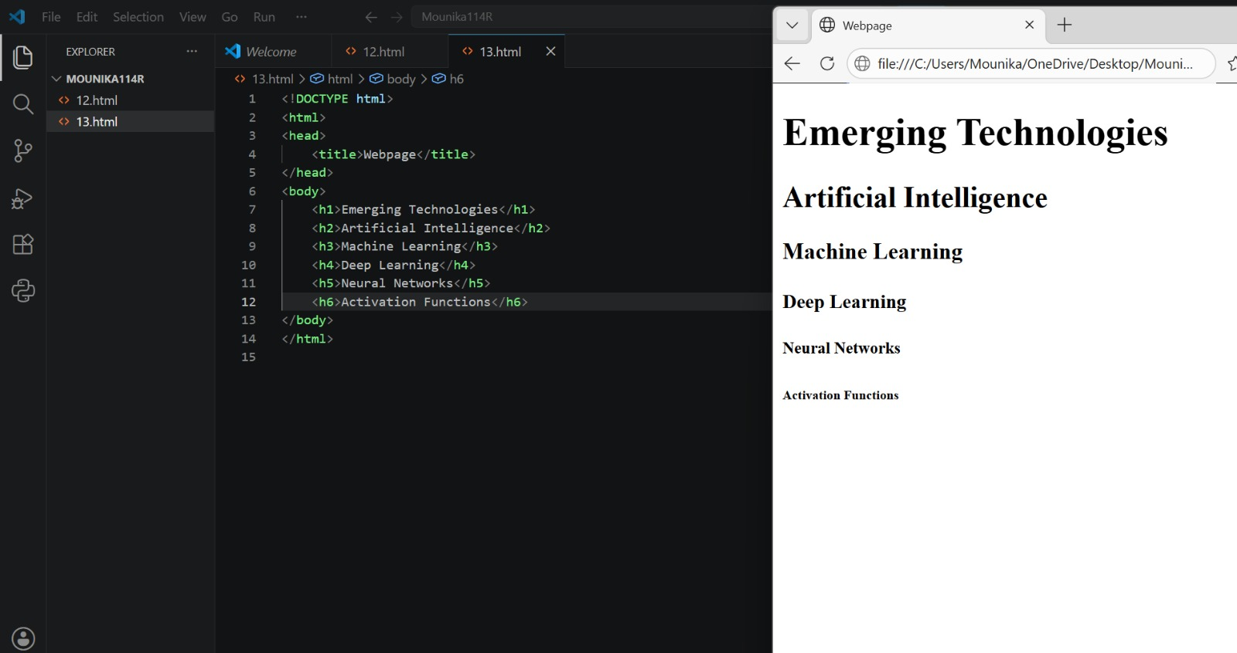
14.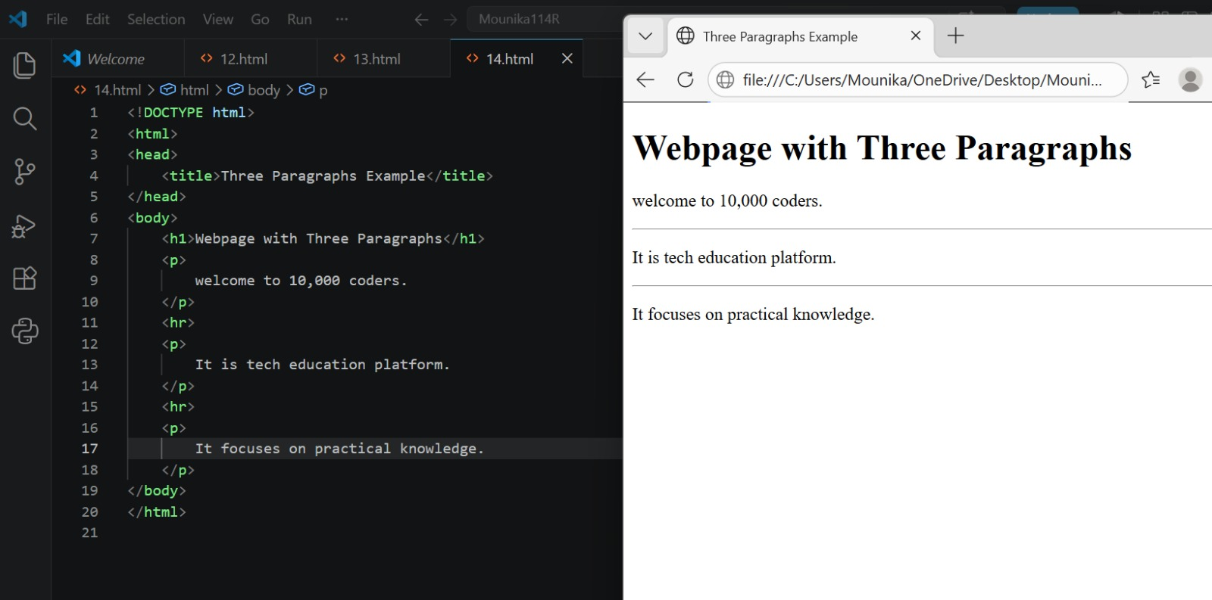
16.
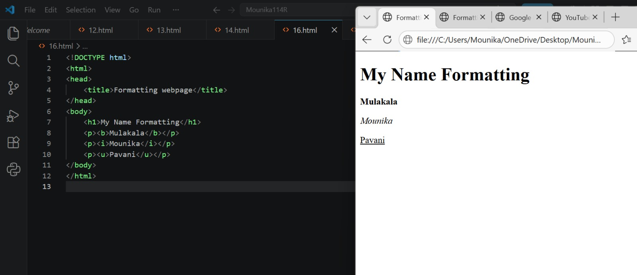
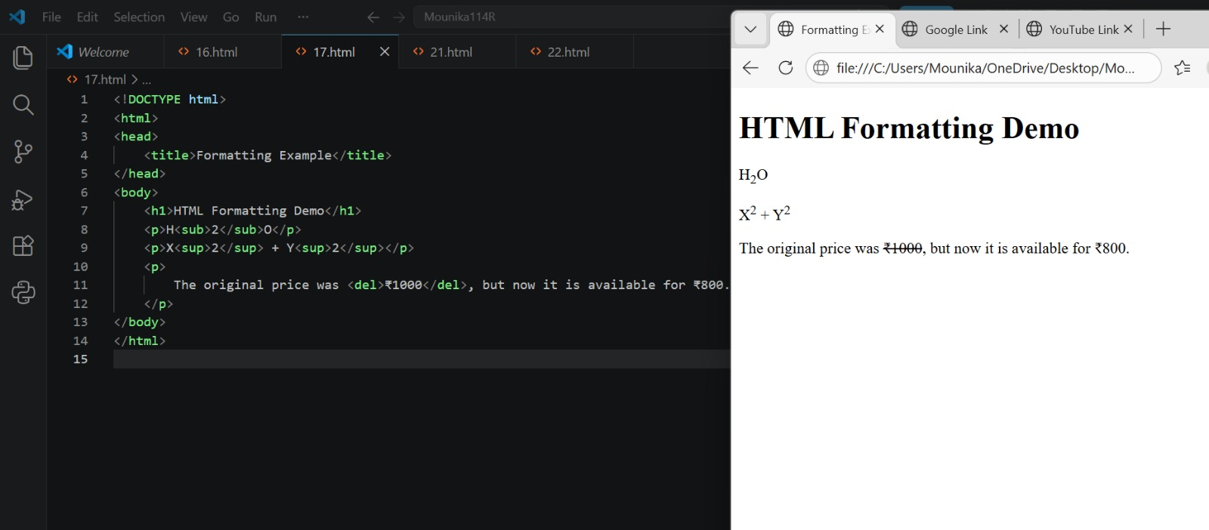

18. What is a hyperlink?
Answer:
A hyperlink is clickable text, image, or button that takes you from one webpage to another webpage or to another section of the same page. Jagadeesh 111R
19. Which HTML tag is used to create a link?
Answer:
The <a> tag (Anchor tag) is used to create a link or hyperlink. Jagadeesh 111R
20. What is the purpose of the href attribute?
Answer:
href stands for Hypertext Reference. Its purpose is to specify where the link should go, such as the URL or address of another webpage.
